EQUATOR RESOLUTION
Commercial & Business Dispute Resolution
Jurisdiction Interface Map
How commercial ADR fits with the DRT, RERA, NCLT/IBC, consumer forums and the CCI
Some commercial matters are reserved to a special forum and are not arbitrable. Getting the forum right at intake avoids wasted time and limitation risk. The map below and the table set out the interfaces.
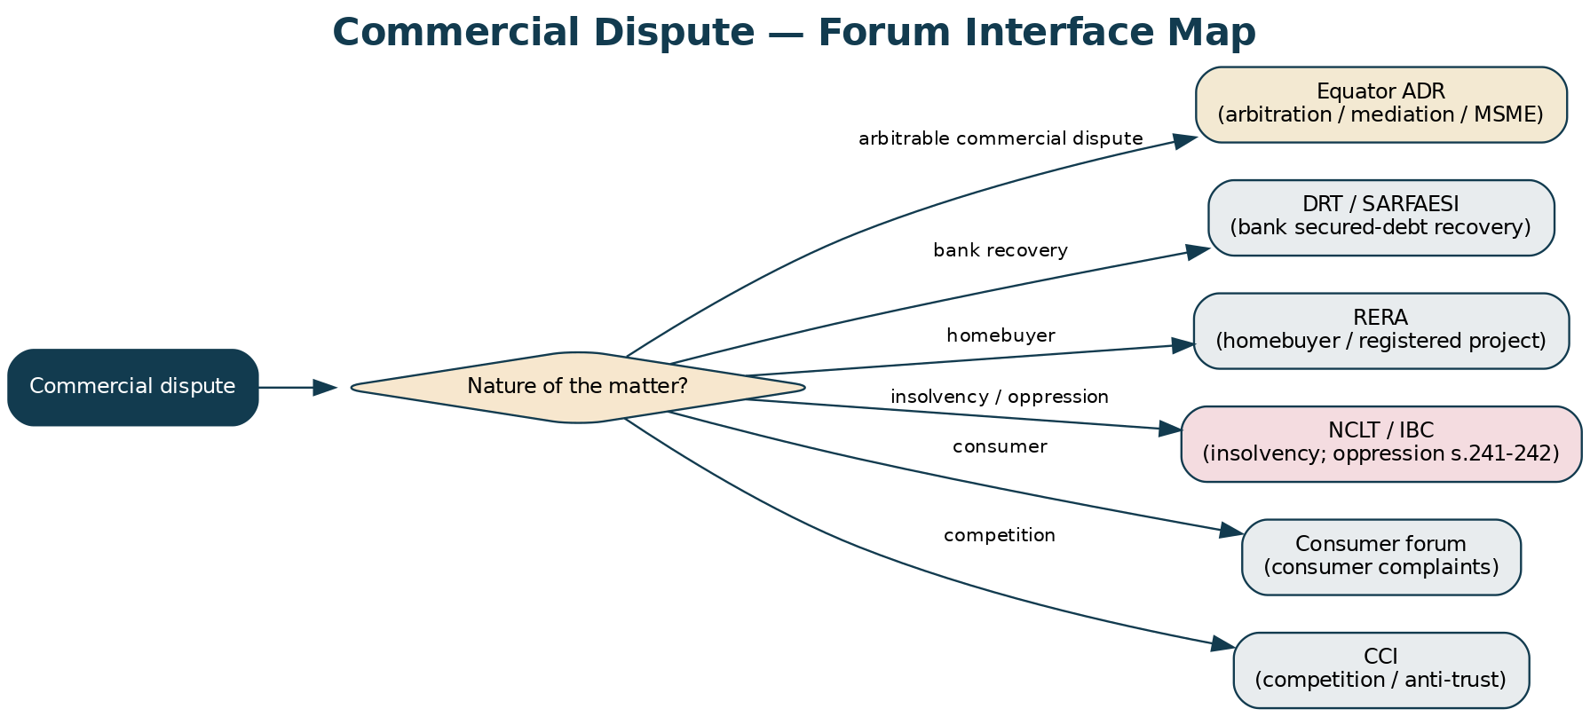
Figure — Forum interface map for commercial disputes.
Forum | Matters reserved to it | Equator's approach
DRT / SARFAESI | Recovery of secured debt by banks/FIs (RDDBFI Act; SARFAESI) | Screen out at intake; take arbitrable commercial-finance disputes (co-lending, fintech)
RERA | Homebuyer complaints; registered real-estate projects | Route homebuyer matters to RERA; arbitrate B2B development/JDA and commercial leases
NCLT / IBC | Insolvency; winding-up; oppression & mismanagement (ss.241-242) | Non-arbitrable — route to NCLT; mediate the commercial reality; arbitrate the contractual layer
Consumer forums | Consumer (non-commercial) complaints | Not arbitrable where a consumer elects the forum; commercial (B2B) disputes are arbitrable
CCI | Competition / anti-trust; abuse of dominance | Reserved to the CCI/NCLAT; not arbitrable
Commercial Courts | Commercial suits (no clause) of specified value | Mandatory s.12A mediation first; then suit; refer to arbitration under s.8 where a clause exists

Table — Forum interfaces and Equator's routing.
RISK / CAUTION
Arbitrability and forum are litigated hard (Vidya Drolia; Emaar/Booz Allen). When in doubt, obtain the tribunal's or a court's view early rather than proceeding in the wrong forum.

